Implement Queue using Stack
Problem Statement: Given a Stack having some elements stored in it. Can you implement a
Queue using the given Stack?
Queue: A Queue is a linear data structure that works on the basis of FIFO(First in First out). This means the element added at first will be removed first from the Queue.
Solution 2: Using two Stacks where push operation is O(1)
Approach :
Push()->
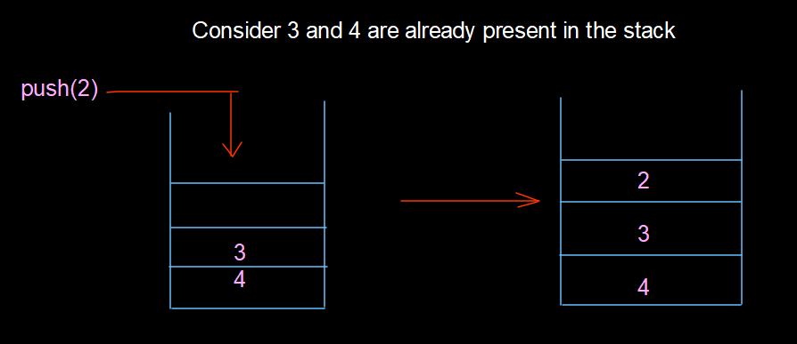
Pop()->
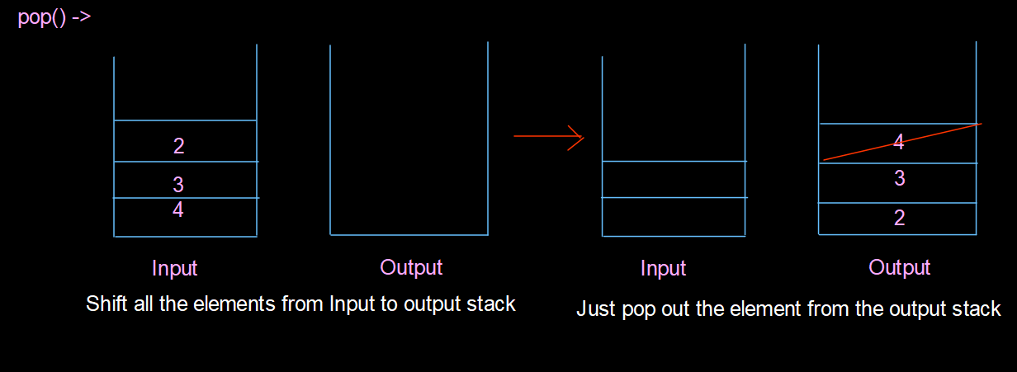
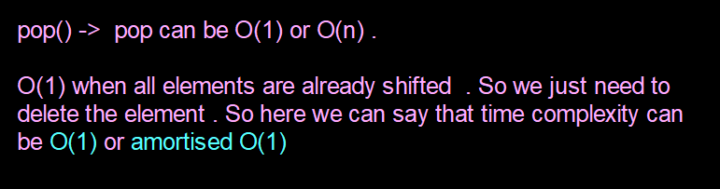
top()->
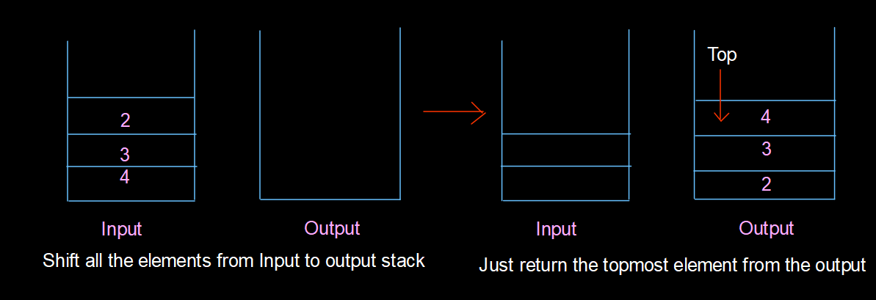
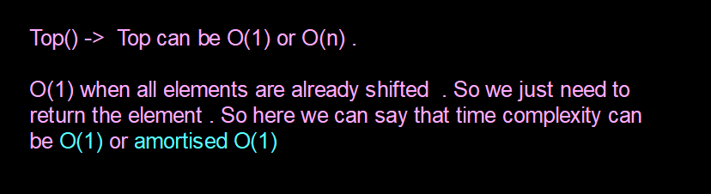
Size():
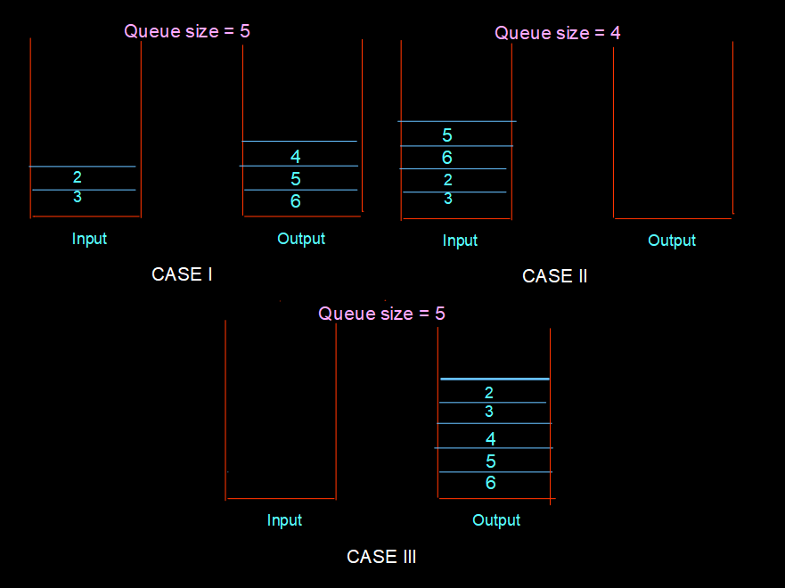

class MyQueue {
public void push(int x) {
input.push(x);
}

public int pop() {
peek();
return output.pop();
}

public int peek() {
if (output.isEmpty())
while (!input.isEmpty())
output.push(input.pop());
return output.peek();
}

public boolean empty() {
return input.isEmpty() && output.isEmpty();
}

private Deque<Integer> input = new ArrayDeque<>();
private Deque<Integer> output = new ArrayDeque<>();
}

